EC2 INSTANCE CREATION:

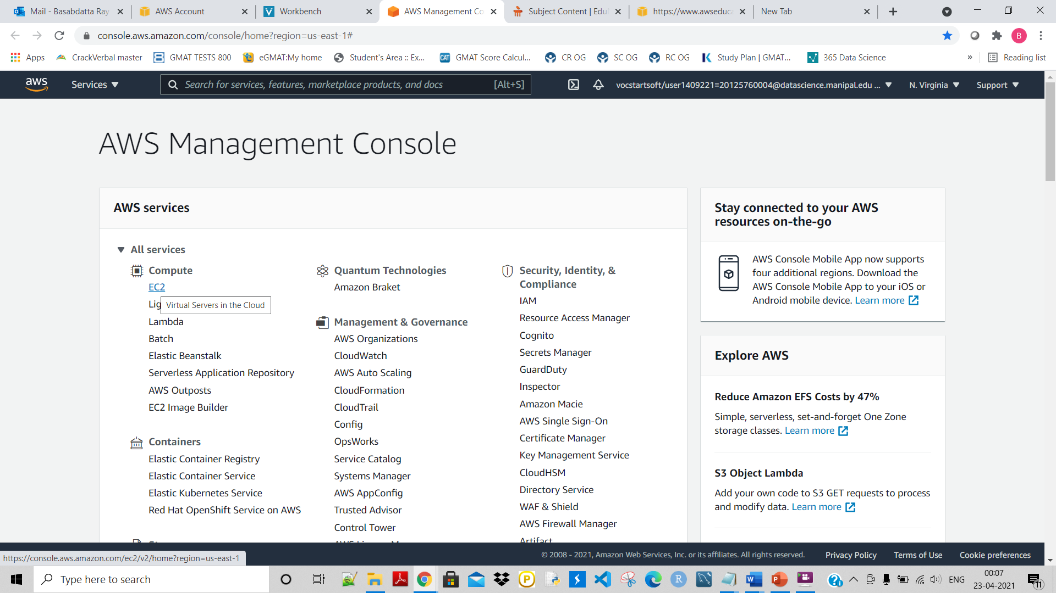

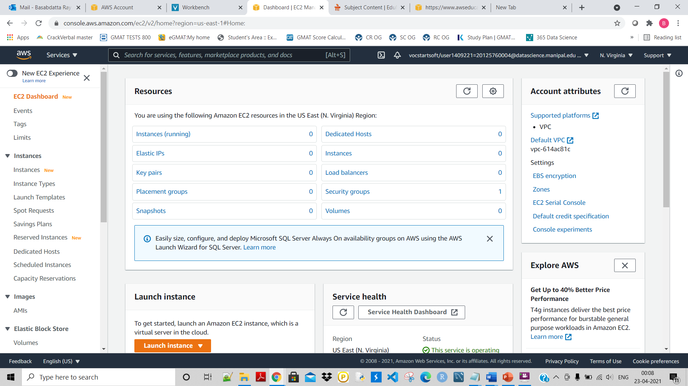

Click on Instances Runing:

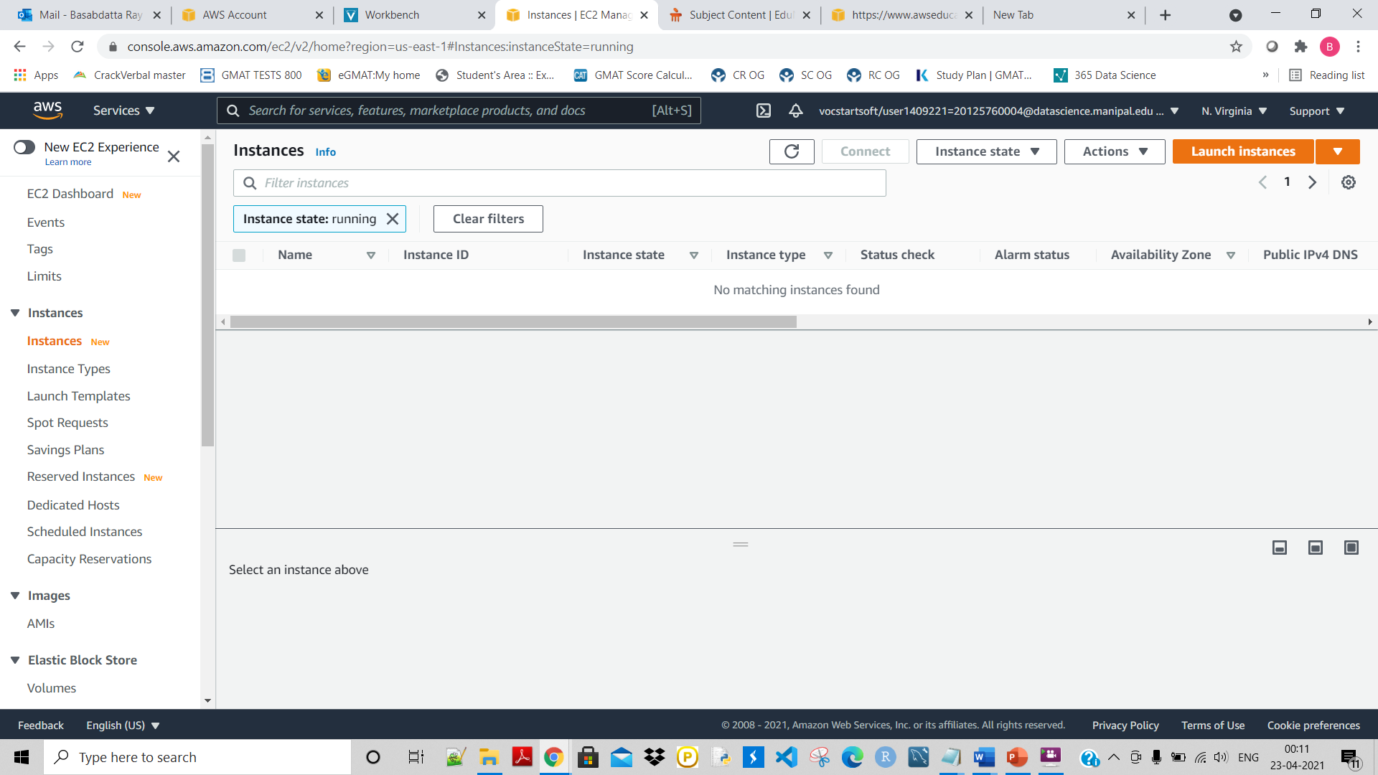

Click on Launch instances:

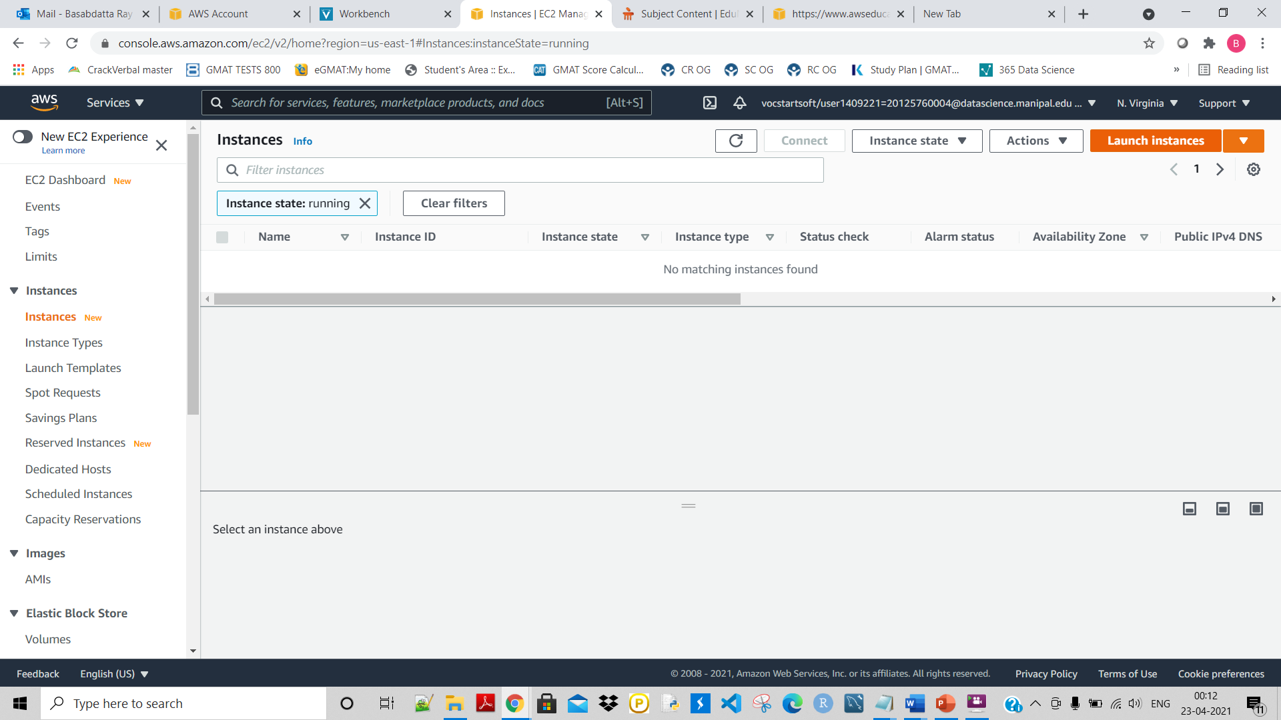

SELECT the 1st one and click on Select

:

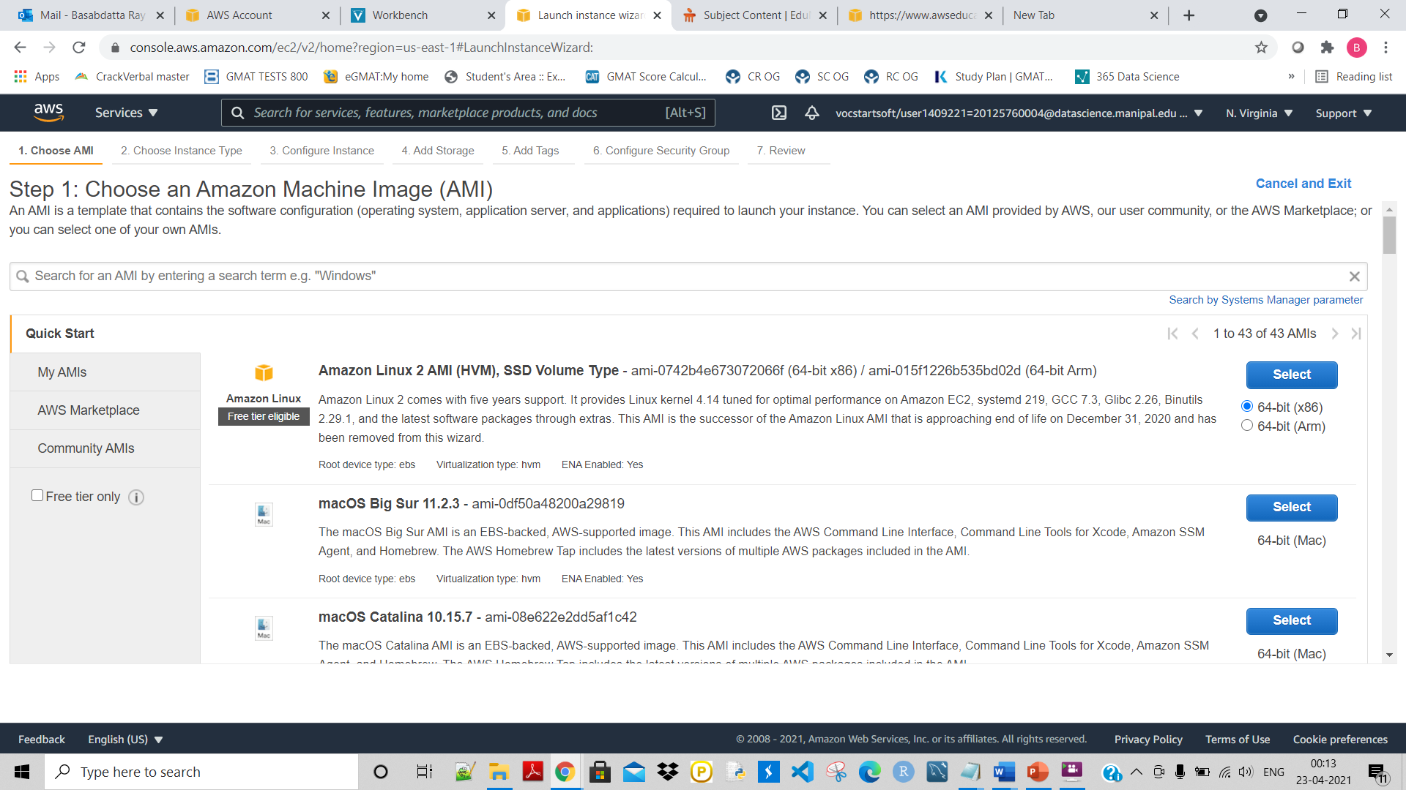

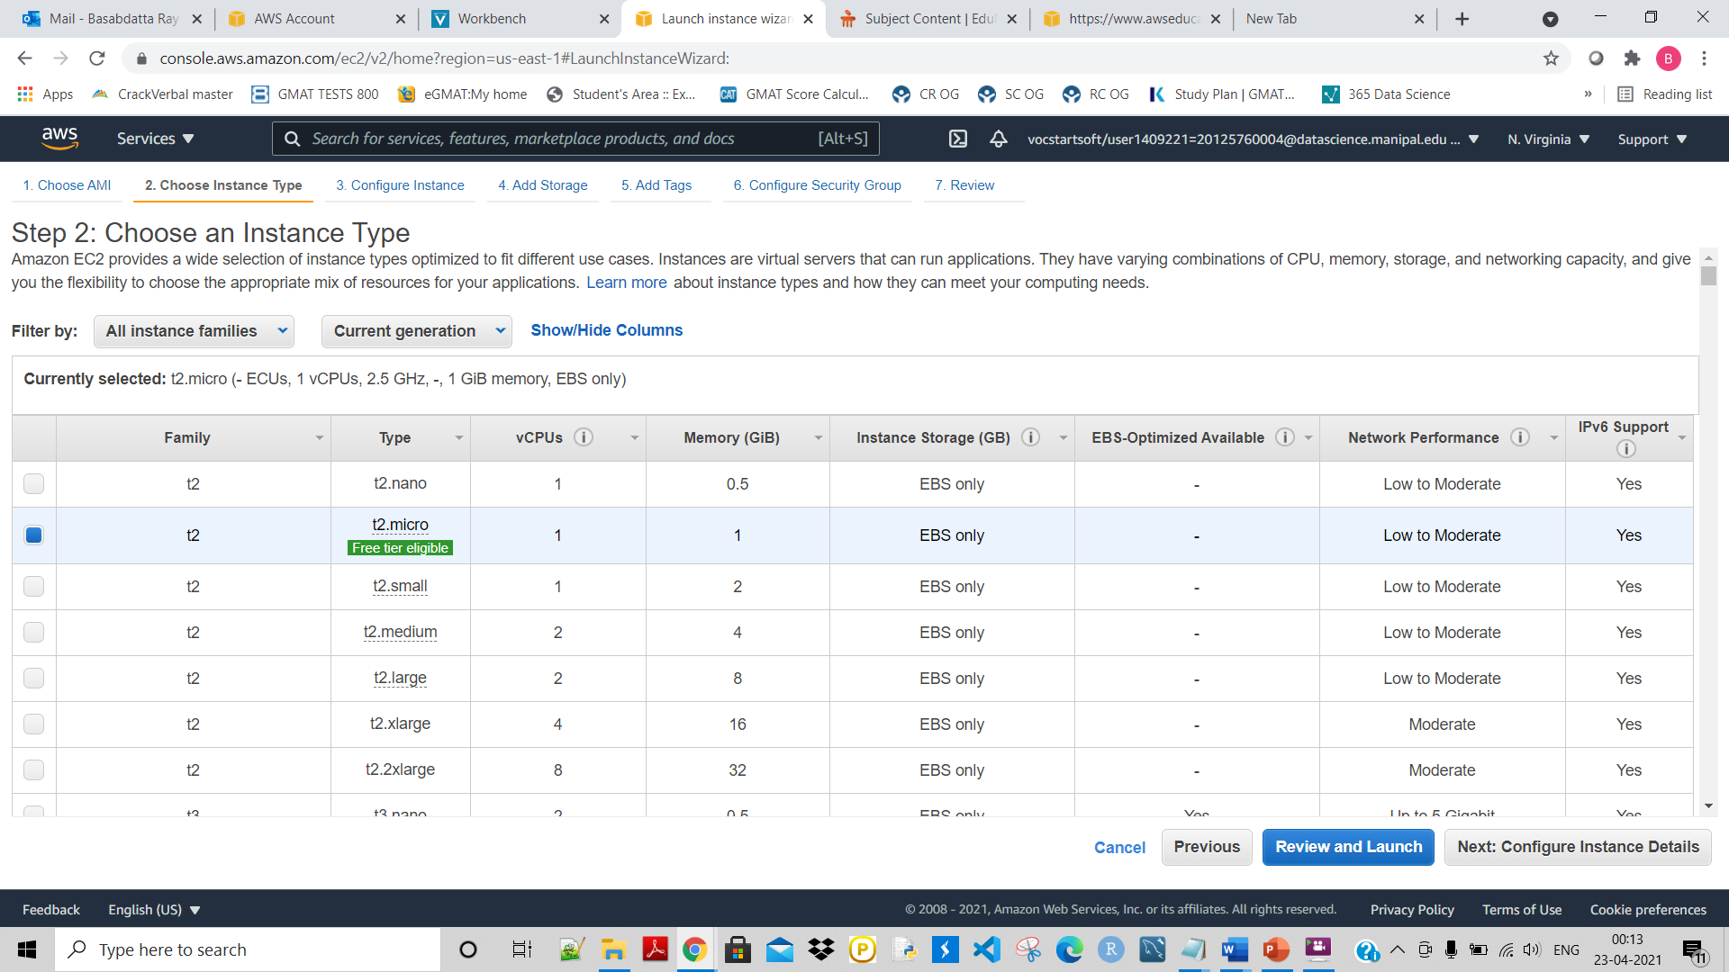

Click on Configure isntacse detaisl:

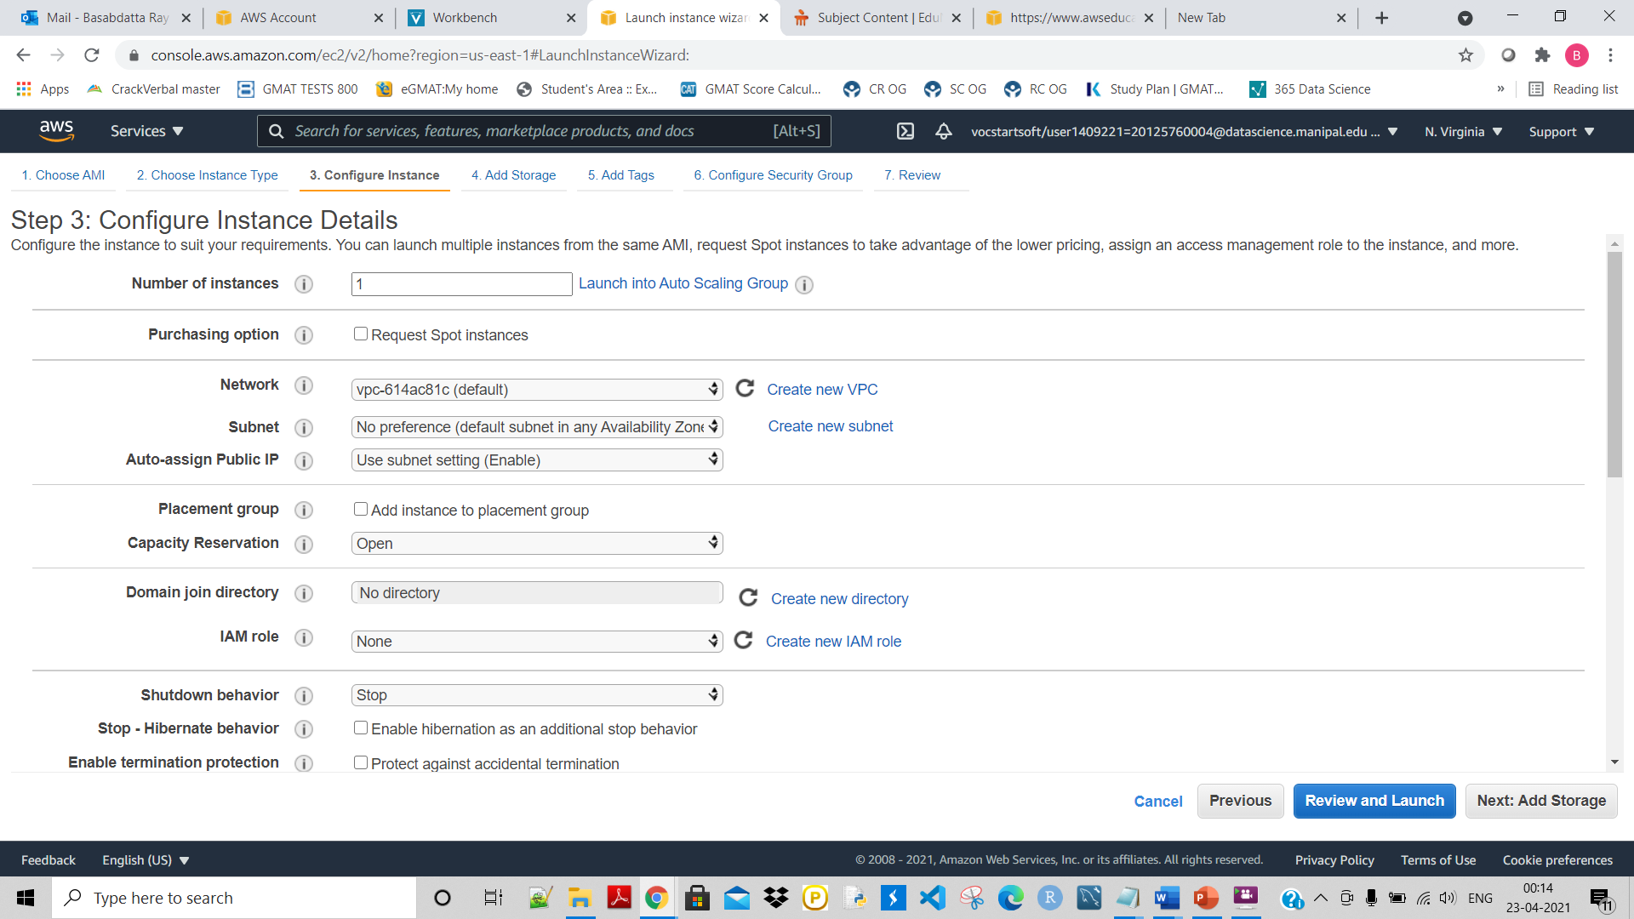

Now give Number of instance=1, and rest leave as it is. Click on Add Storage

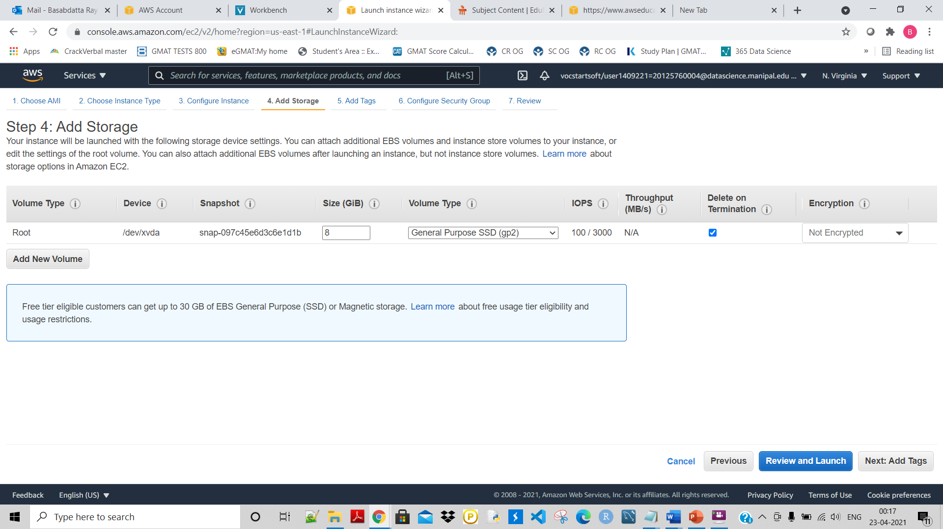

Click on Add Tags:

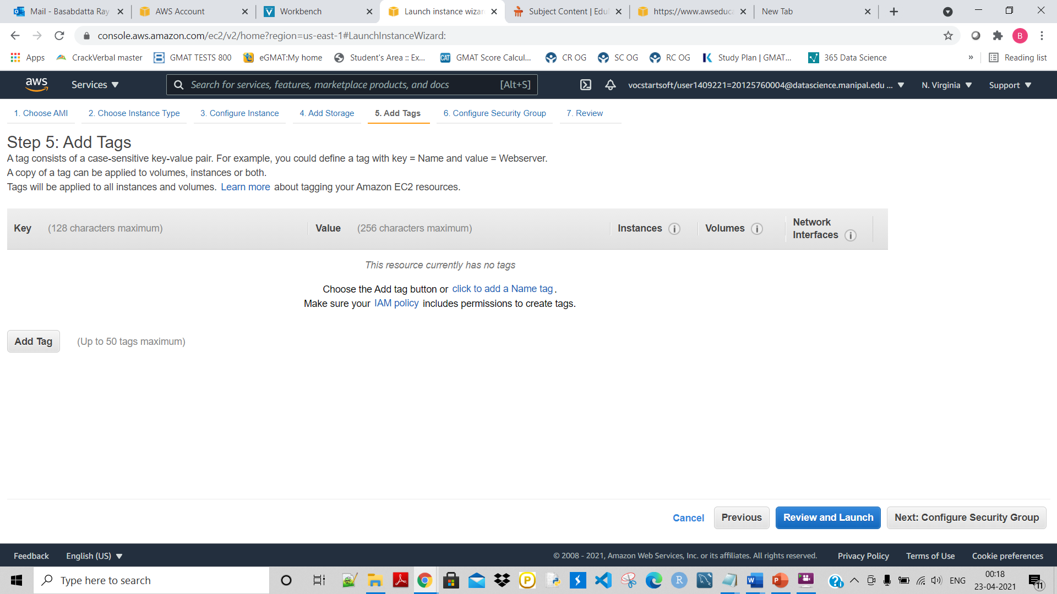

Click on Configure Security Group

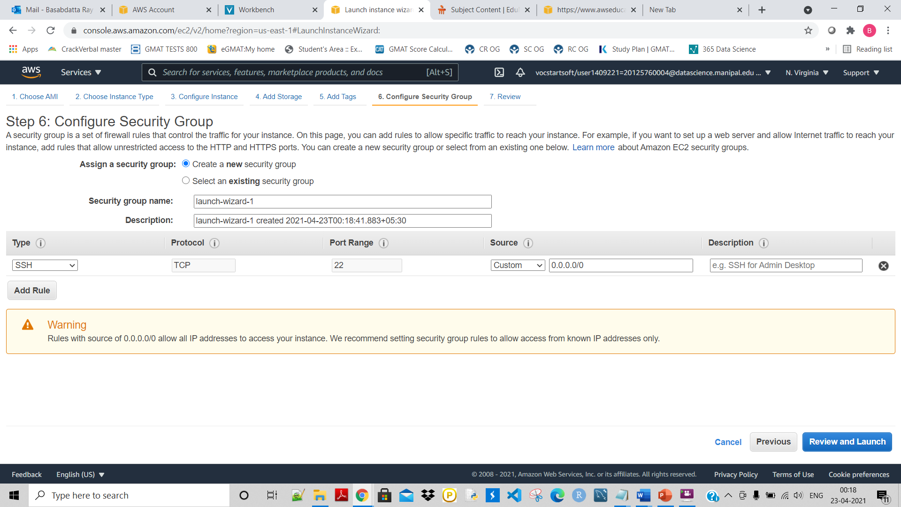

From here it is important. All the inbound and outbound rules will be specified here in the above screen. Now give a **Security group name : Instance01-sg**

**Here by SSH port I am connecting to it. If want to connect to the EC2 VM through HTTP then click on ‘Add rule’ and from drop down select HTTP:**

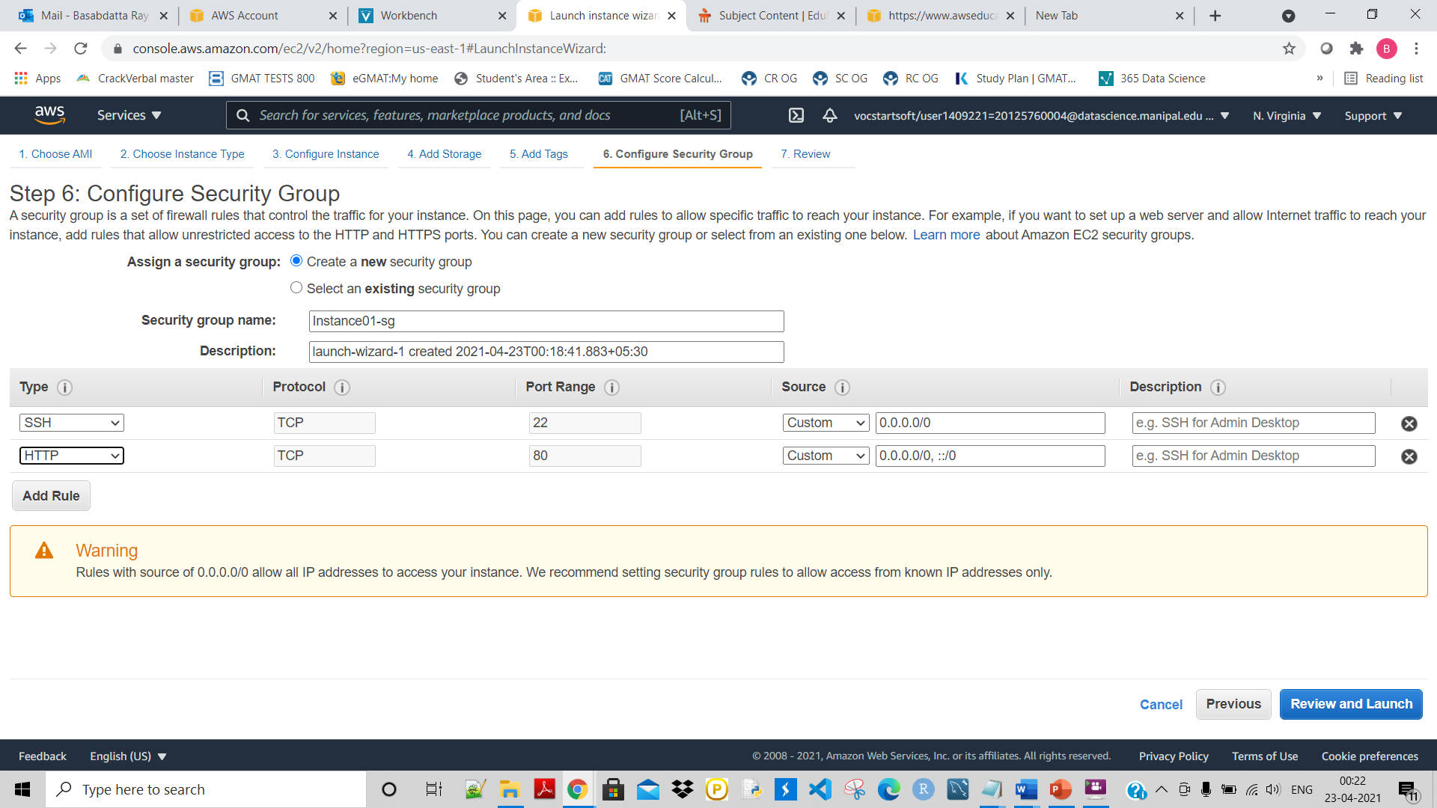

But for this instance I am connecting through SSH only. Here as leave the custom IP as : 0.0.0.0/0, it means I am allowing all to access it.

Click on Review and Launch:

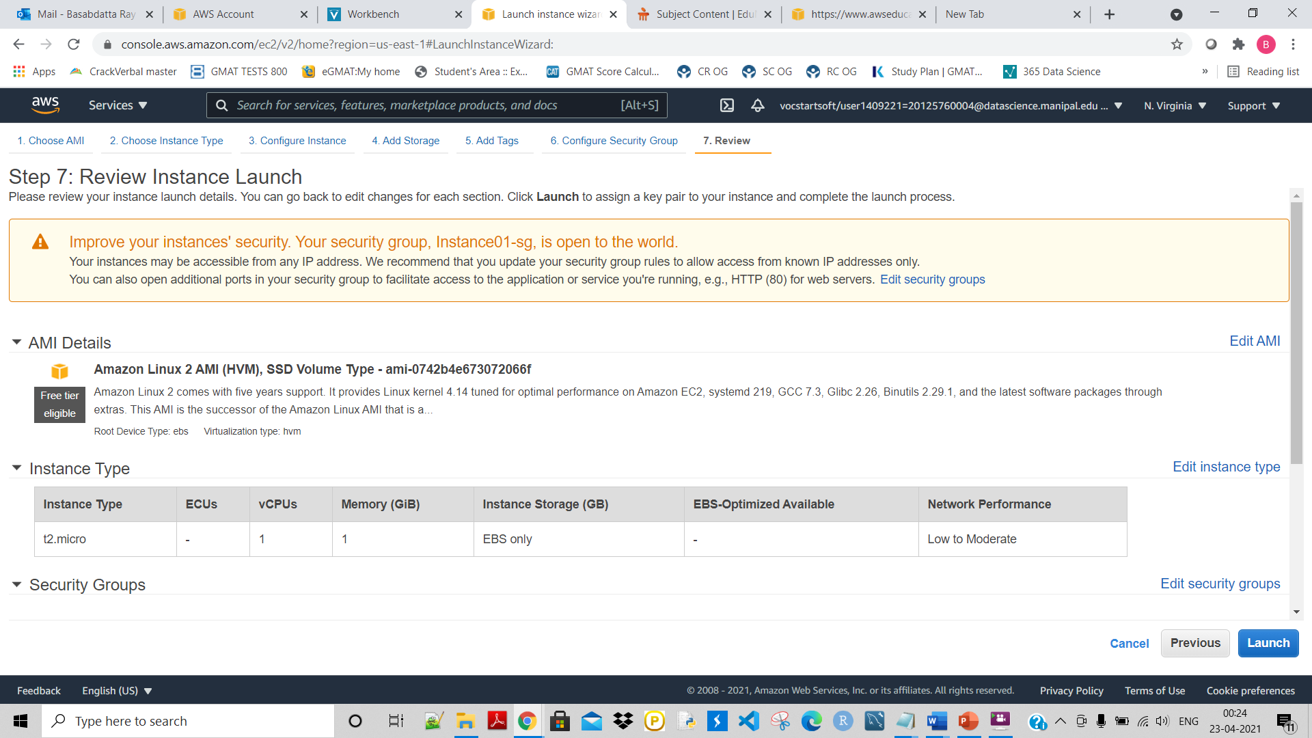

Click on Launch:

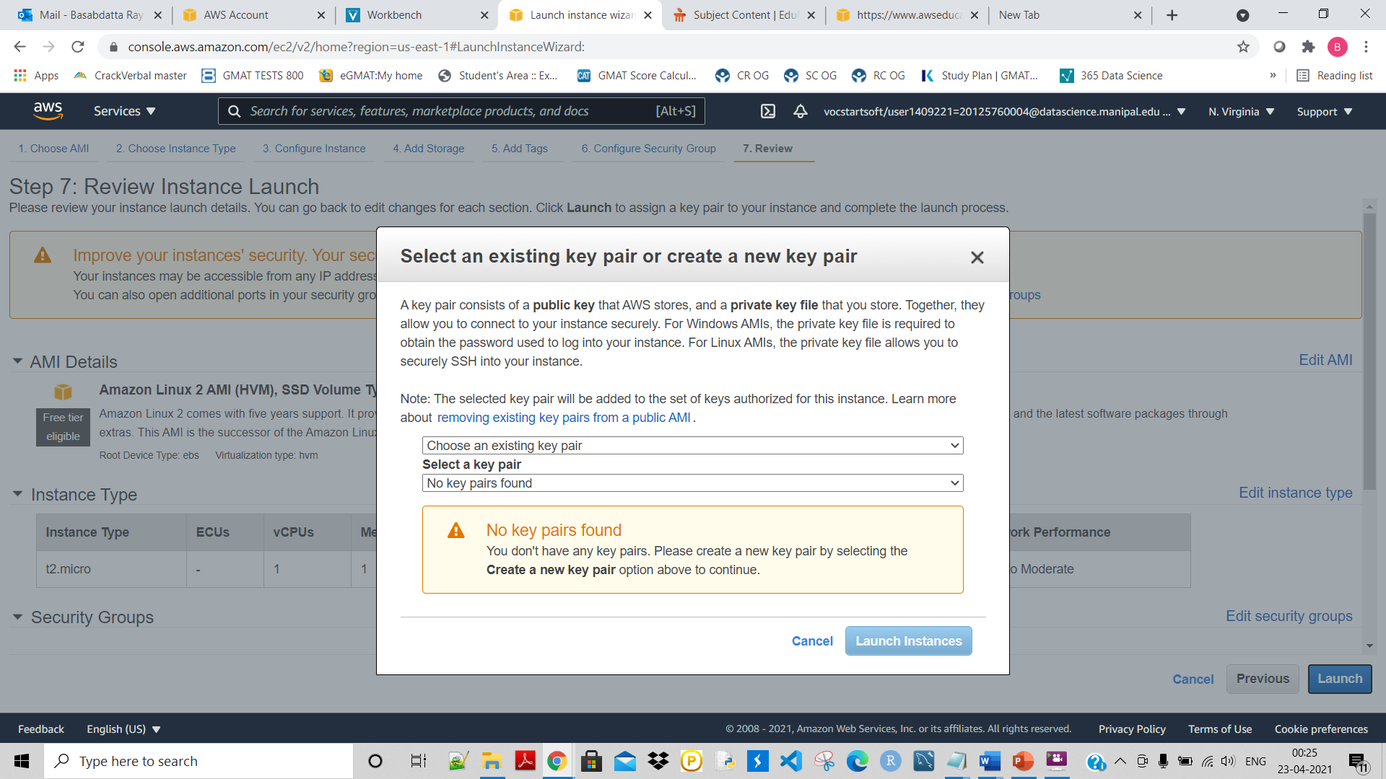

Here very imporantn. Here select Create a new key pair and give some key pair name : instance01-kp-004. Then click on Download key pair to save this:

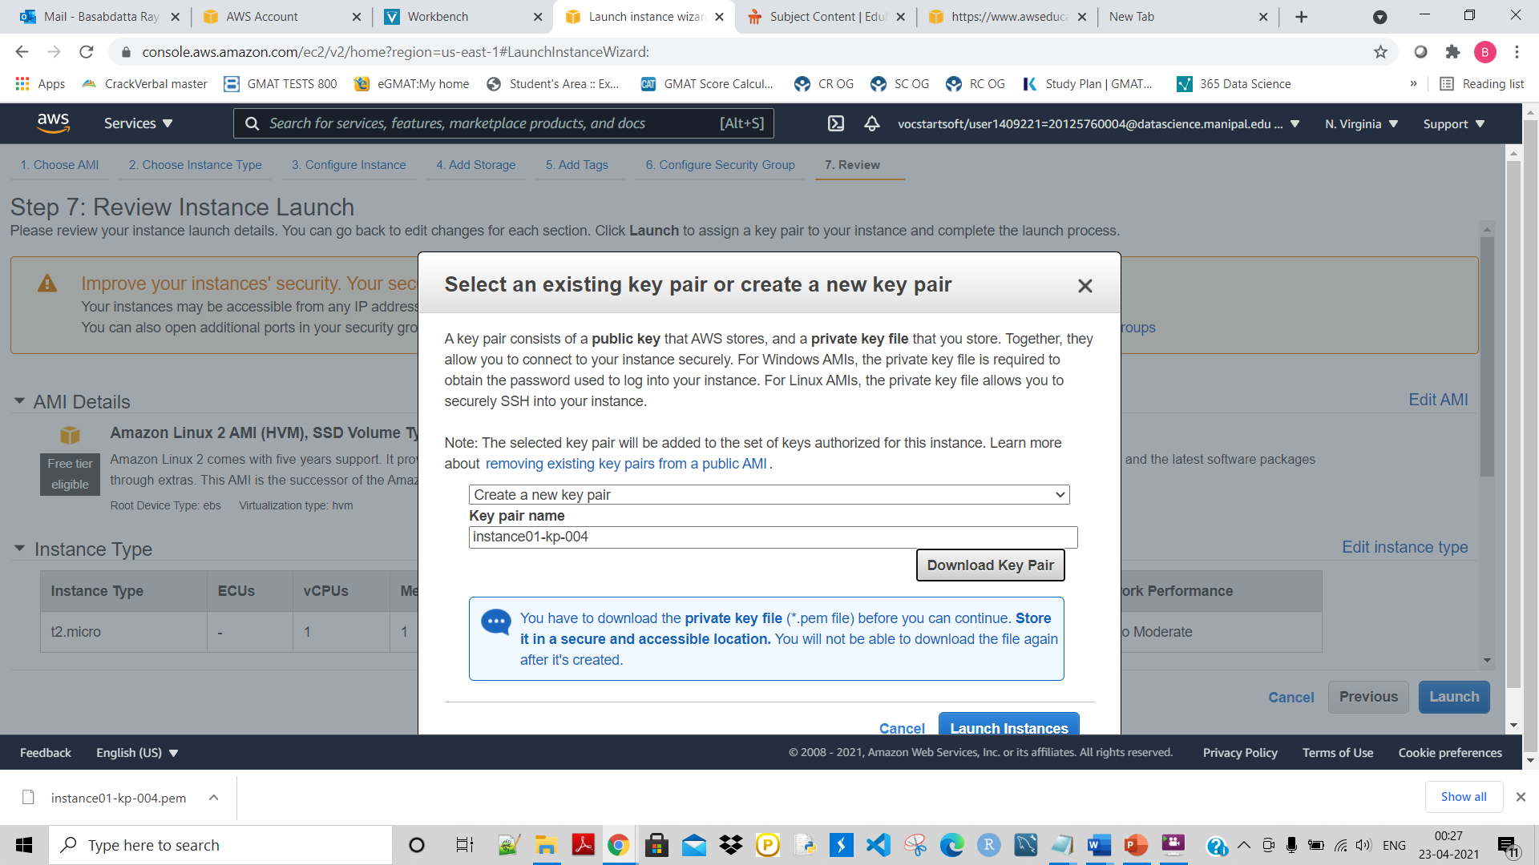

As shown above now it is doenloaded to me system.

Next click on Launch Instances:

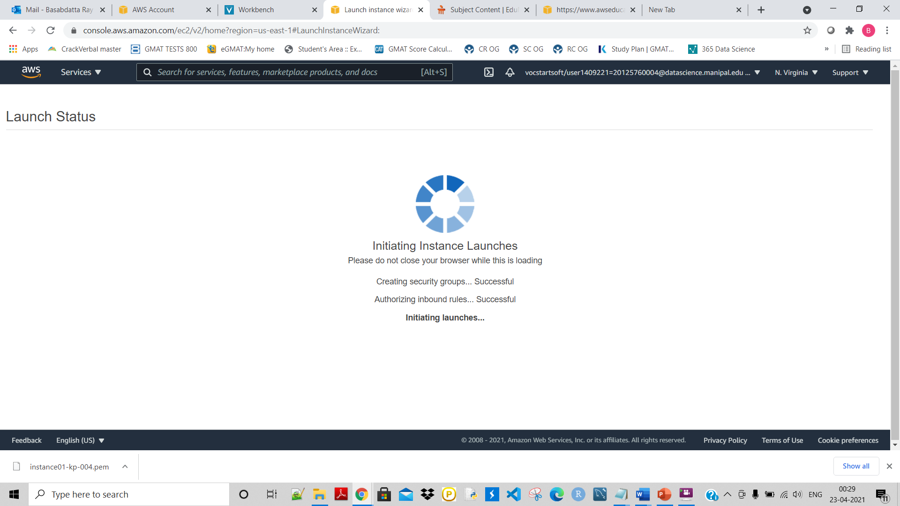

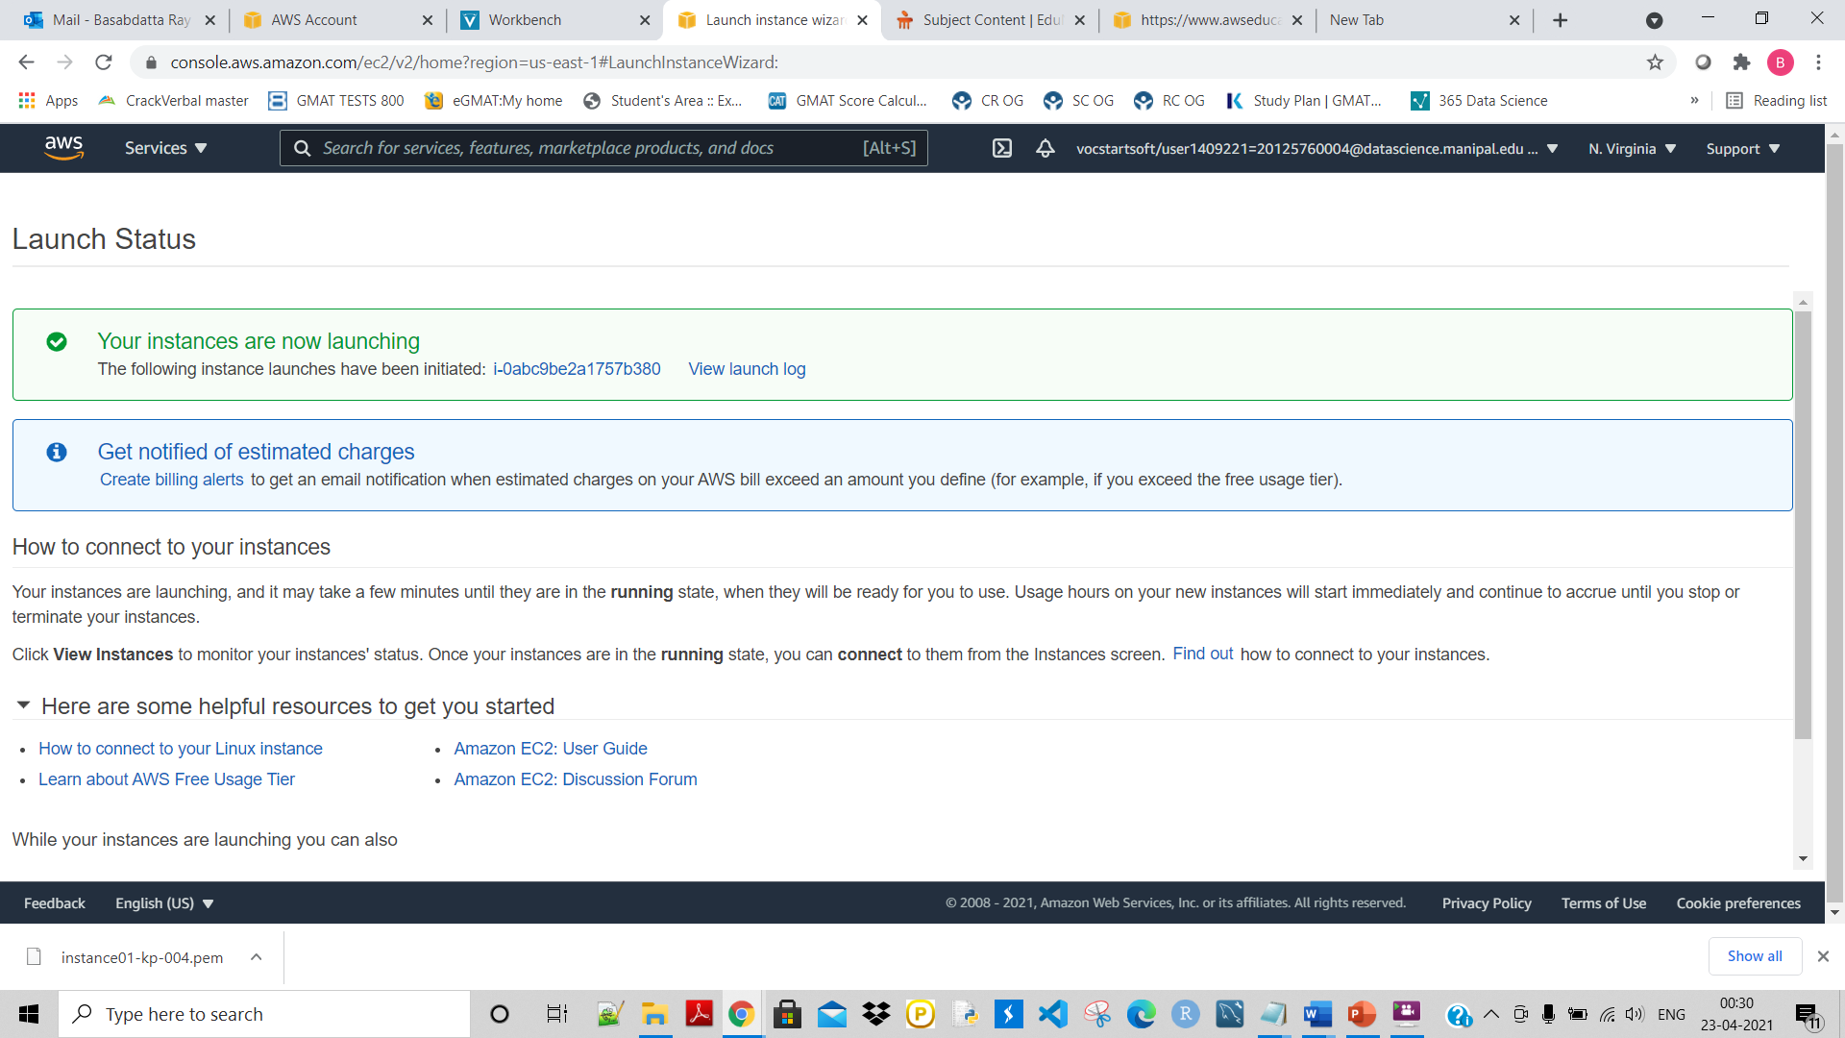

Click on the highlighted part to see if the instance has been created or it is running to create:

So it is showing as ‘Runing’:

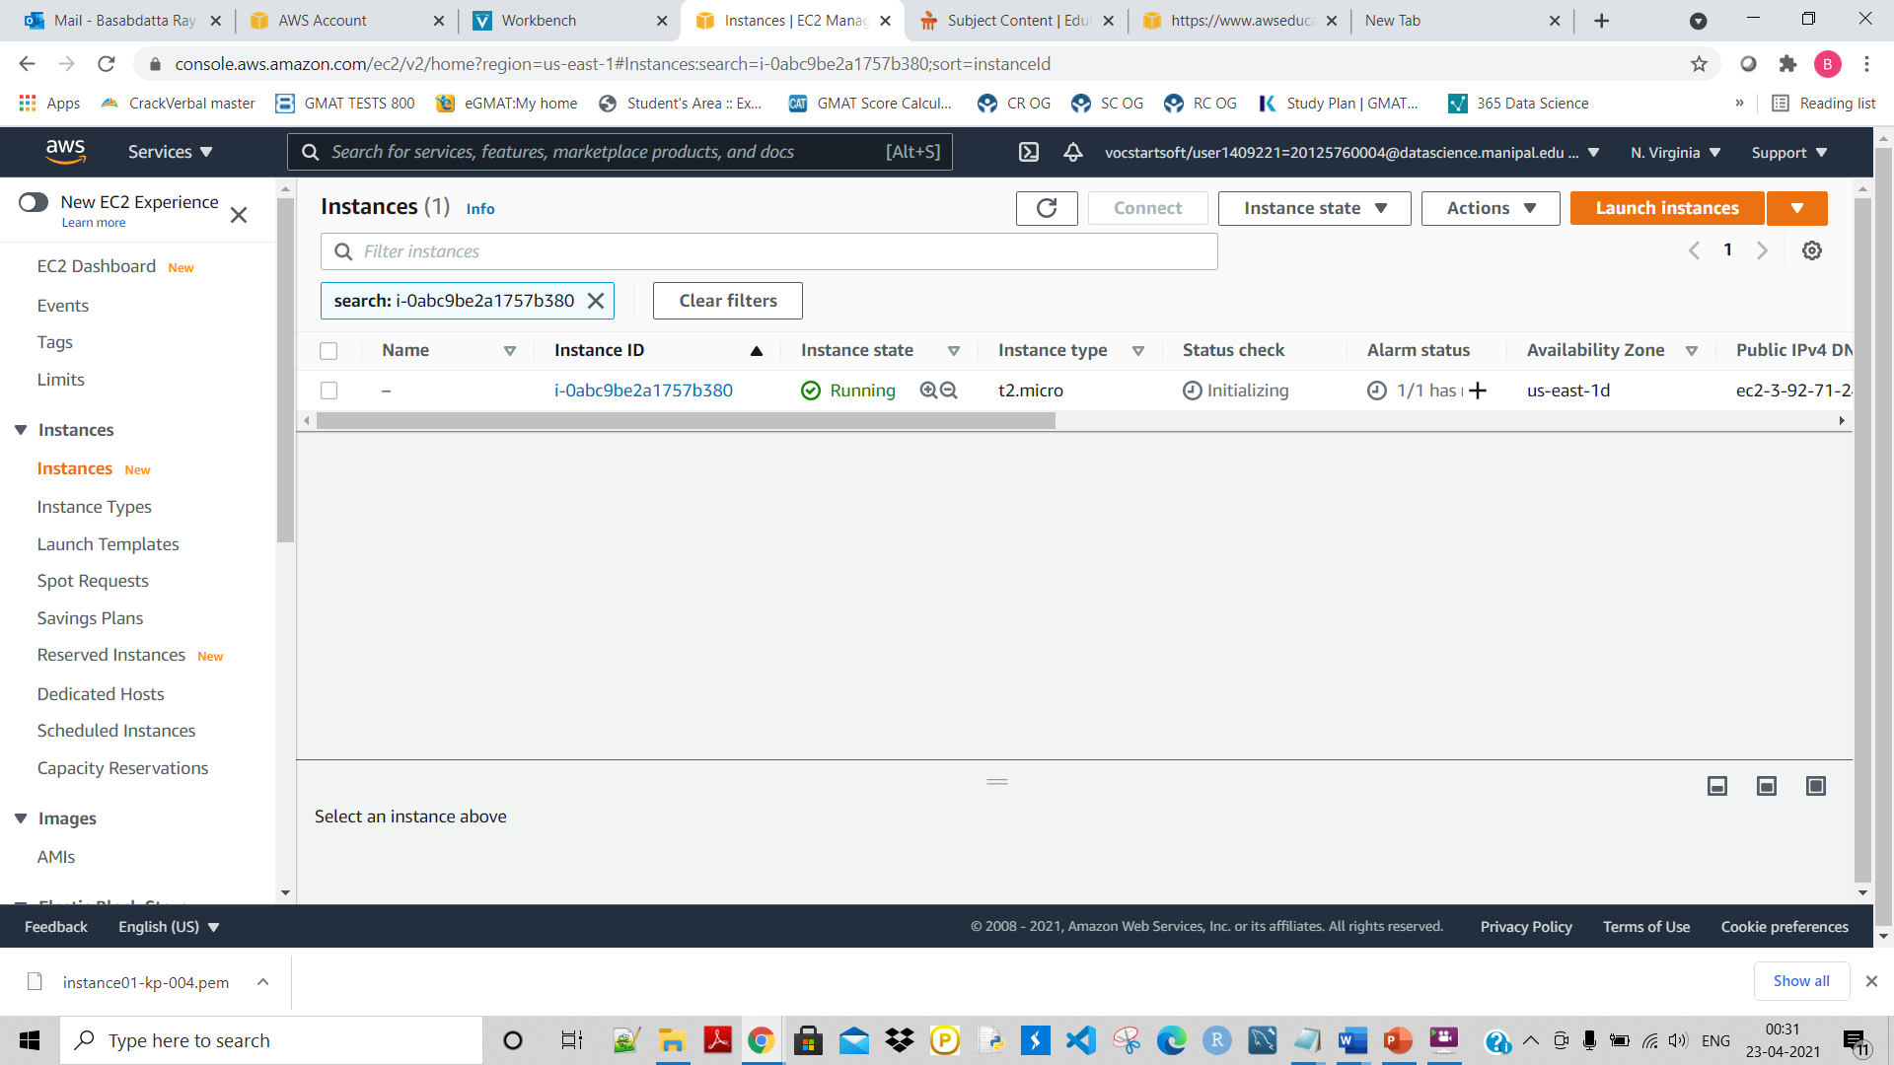

Give a name or tag to it like this:

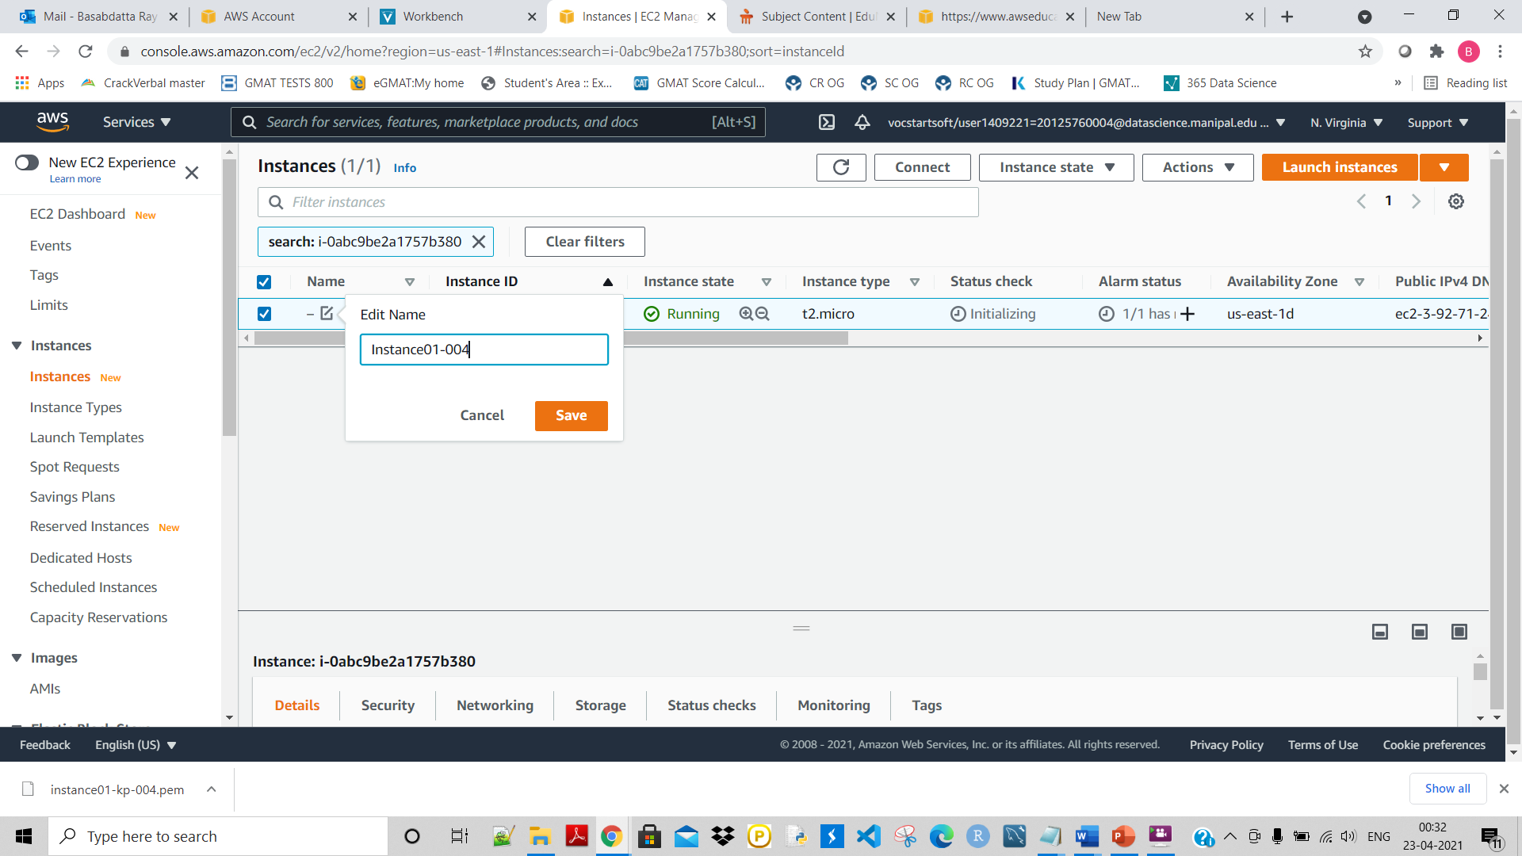

Ran because it shows 2/2 Checks passed:

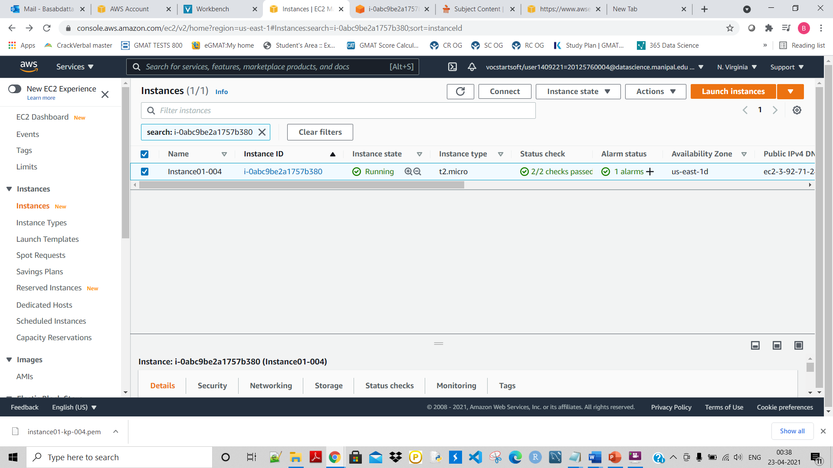

Nest Click on Coonect:

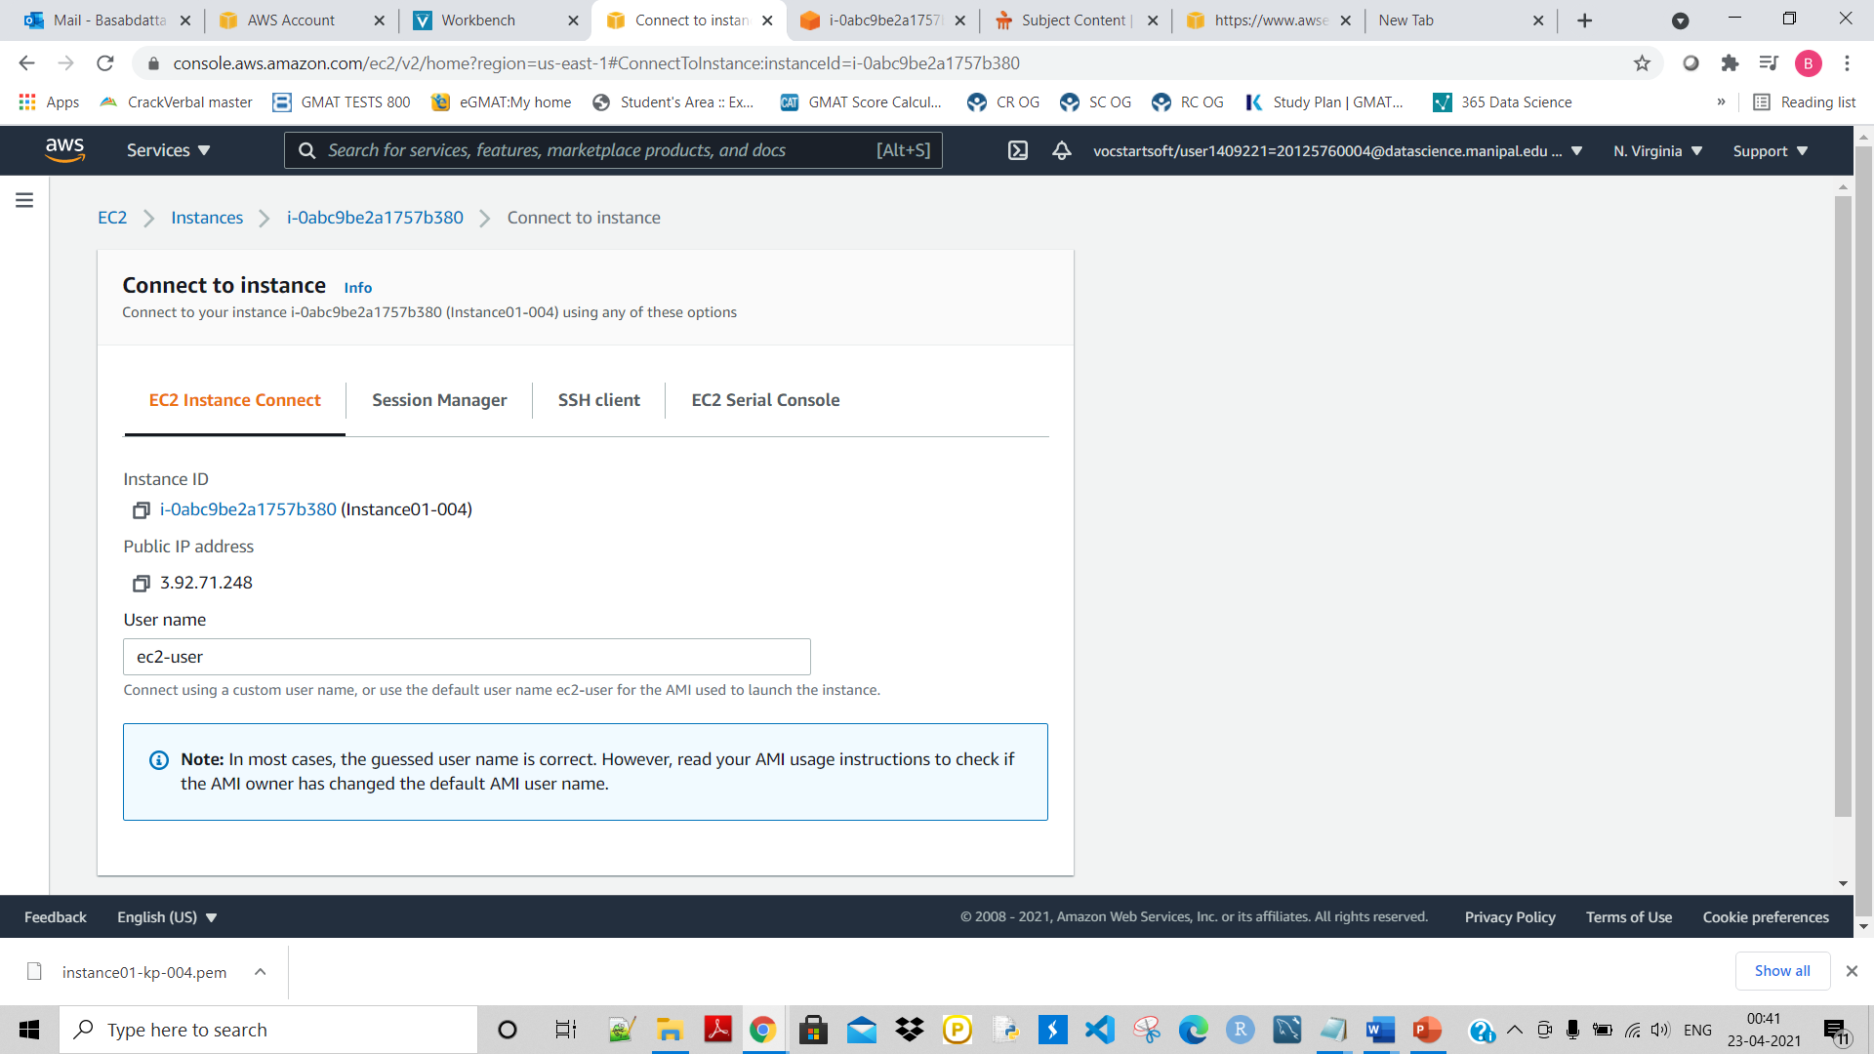

Next here also click on connect but showing error:

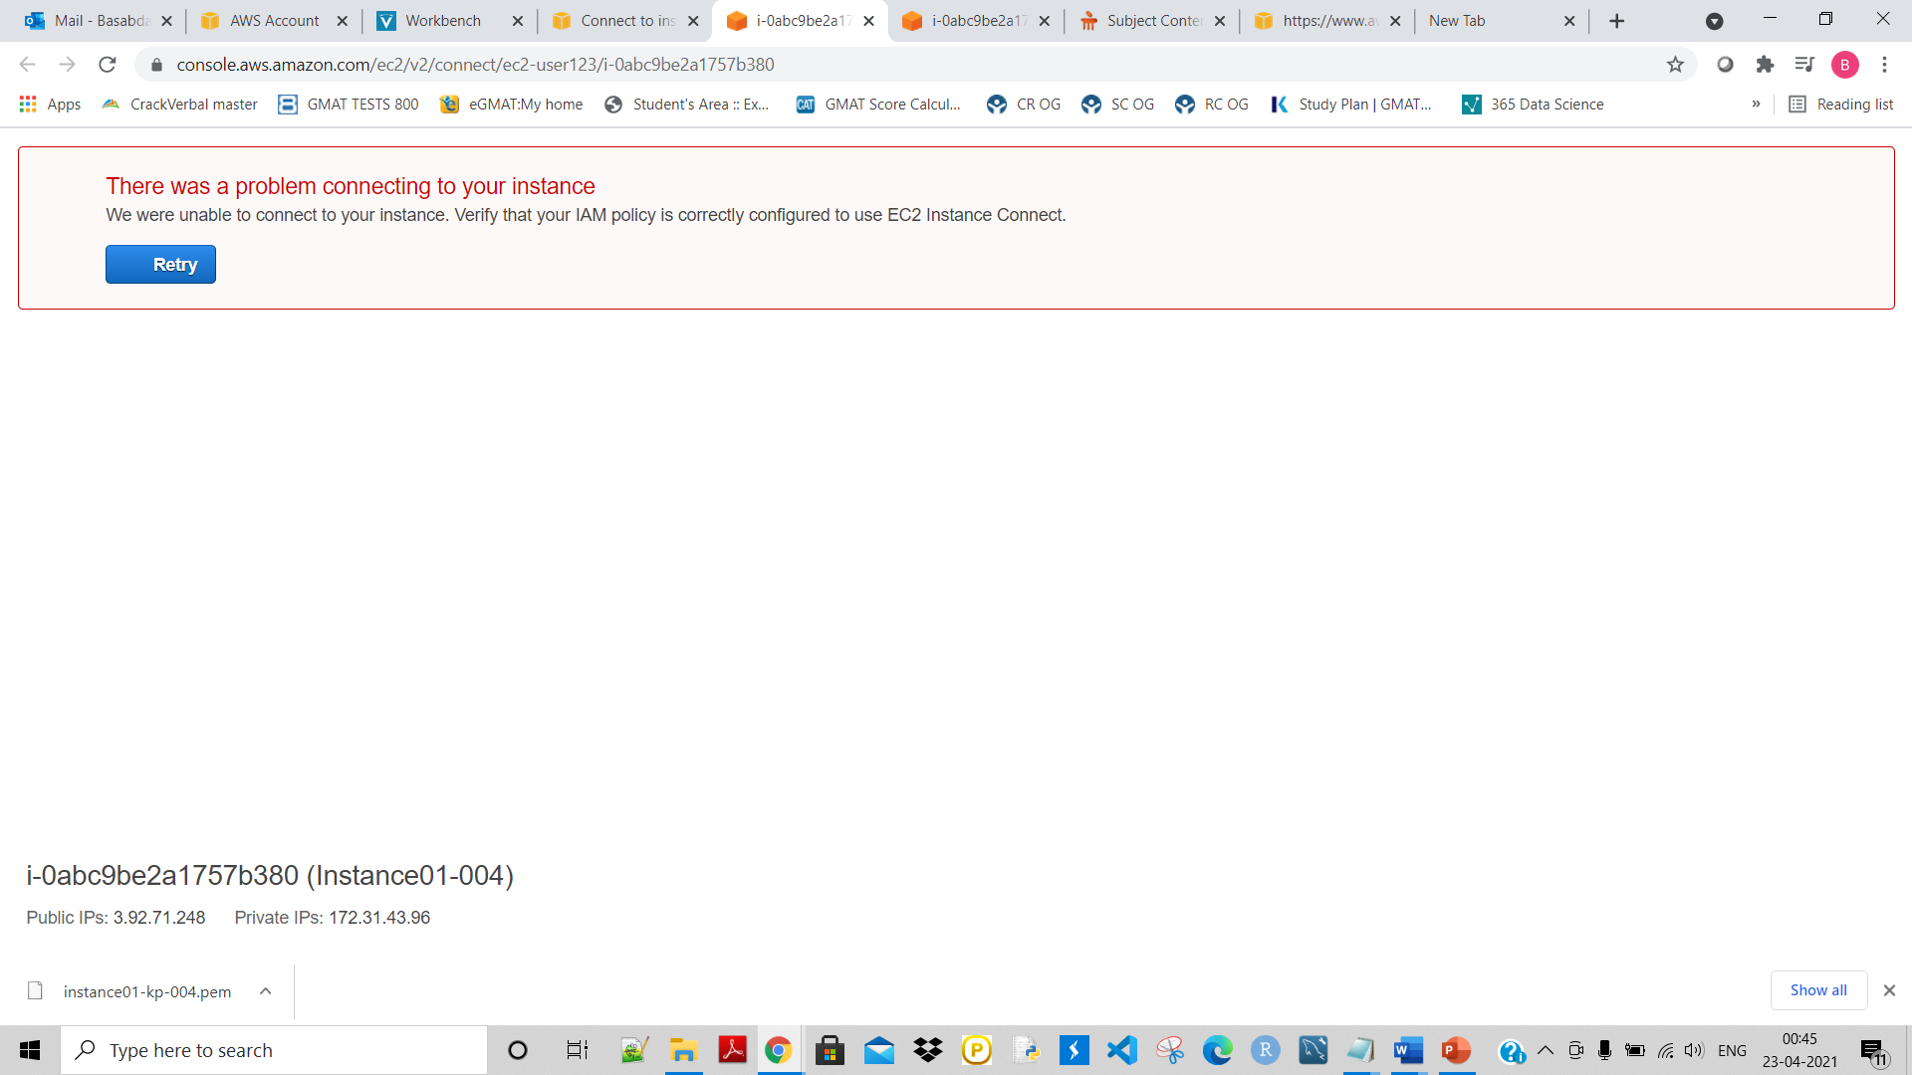

It is showing:

